Final Project Report

A Report Presented to
The Department of Computer Science & Software Engineering
Concordia University

In Fulfilment
of the Requirement
of COMP 371

by
Dan Raileanu (ID: 40019882)
Mohamed-Yasser Houssein (ID: 27650922)
Mohd Tanvir (ID: 40014010)
Muherthan Thalayasingam (ID: 27223064)
Radhep Sabapathipillai (ID: 40033092)

Concordia University
August 2020

Starting Point
After Assignment 2, we had the following program structure to work with.
Note that some non-important methods are not shown for simplicity. Also the Model class used to create the Student Models in assignments is not included since not needed for project.
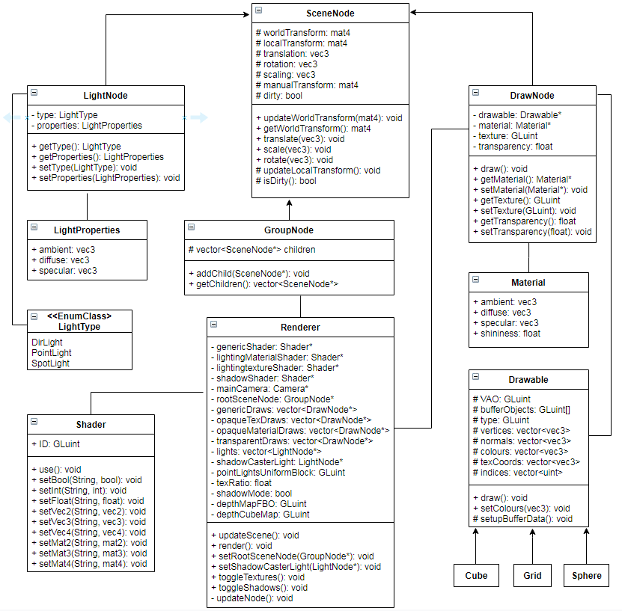
We have a good Hierachical Model in the form of SceneNode and classes that inherit from it.
-SceneNode has the default implementaiton for spacial transformations that all nodes inherit.
-GroupNode is only class allowed to have children, thus any complex Model should inherit it.
-DrawNode is only class allowed to have a Drawable geometry and has a draw().
-LightNode holds the required parameters for lights. Currently only supports PointLights.
-Drawable has the Buffer Objects to contain all the geometry and a draw() that has OpenGL draw it. Everything that needs to be drawn has to inherit form it.
The Renderer class has a low cohesion, as it does too much. It currently handles traversing the tree from the rootSceneNode, updates nodes’ spacial transforms and sorts all nodes into appropriate vectors. It sorts DrawNodes in different categories and each requires a different shader to be drawn. Note that only transparentDraws absolutely require to be sorted appart, as they have to be sorted back to front and drawn at the very end, but we decided to sort all of them to reduce number of shader swaps. It also allows us the option to sort the DrawNodes dependig on texture/material in order to reduce setting uniforms between draw calls.

Planning
We decided to go with the Rubik Cube option. The main reason is that we have a good Hierarchical Modeling and are most familiar on how to manipulate objects in space, which seems to be the main objective in designing a rubik cube.
What we plan on implementing:
- Basic rubik cube that simply has different colours on each face (counts as 1 puzzle).
- Inherit from base RubikCube and add texture implementation of a jigsaw puzzle.
- Inherit from base RubikCube and add particles implementation. Particle colors will represent the different colors of a rubik cube.
- //TODO find 4th puzzle
- Display timer. Have a 3D Model made of digits in TimeX format that change in such a way to increment timer every second.
- Modify shaders to add Billboards imeplementation, thus having the timer always face the camera, so it looks like part of an interface.
- Create SkyBox
- Create an arcade ambiance by having some flashy animations, like lines going around or some shapes doing something interesting. Even better if procedural.

Implementation
Dan Raileanu
- Basic Rubik Cube implementation:

